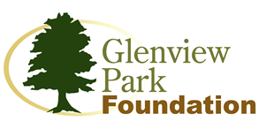
Application for Membership on the Glenview Park Foundation Board
The goal of the Glenview Park Foundation is to support the park district in the delivery of recreation programs, services, and facilities as well as providing healthy recreational events for the Glenview community.
Applicants for the Glenview Park Foundation Board are required to complete the following application and return to the attention of Amy Wille, The Glenview Park Foundation, 1930 Prairie Street, Glenview, IL 60025.
Name: |  |  |  | Work Place:
 |  |  |  | Position:
Address: |  |  |  | Address:
City: | ST: IL |  | ZIP: | City: | ST: NY | ZIP:
PH: | FX: |  |  | PH: | FX:
Cell: |  |  |  | Wk Email:
Email:
- Please explain why you wish to join the Glenview Park Foundation Board.

- What special knowledge/qualities/expertise do you bring to the Foundation that would help to support the goals and mission of the Foundation?
- Community Activities
Organization Position Held Dates of Membership
- How many years have you been a resident of Glenview?
- Please attach a brief resume to this application.

My signature below indicates my interest in serving on the Glenview Park Foundation Board and that I have read and fully understand the Foundation By-Laws.

Signature: Date: Click here to enter a date.

Thank you for your willingness to make a difference in your community by offering your time and service. Please send this application to the address listed below.

Glenview Park Foundation, ATTN: Amy Wille 1930 Prairie Street, Glenview, IL 60025 Amy.Wille@GlenviewParks.org

